YP Summit 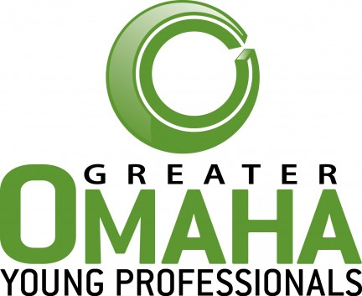

Yesterday I attended the Greater Omaha Young Professionals Summit at the Century Link Center. I think that the focus of the summit was to get young professionals involved in their community. Well, hook, line, and sinker-they got me. More on that in a minute. I did learn about issues that I don’t think I would have stumbled upon otherwise.

Open Sky Institute, a non-profit, non-partisan organization out of Lincoln, should be your go to for any state budget questions-a group of really sharp individuals (http://www.openskypolicy.org/). They led the breakout on state budget.

I learned that Nebraska’s tax code hasn’t been revised since the 1960’s and this is leading to a downward spiral that includes funding for K-12 education being cut $100 million in two years. These kind of numbers always shock me- how did THAT happen? This year there is going to be a review on Nebraska’s Biennial Budget-hearings began this week. What can you do? OpenSky recommended talking to our senator, Mike Johanns. Know your facts, send letters, call, emails may be ignored. The senator will hear from 100 lobbyists but maybe 5 citizens. All the other breakout sessions I went to were packed-this one had maybe 50 people in it. The state budget doesn’t sound exciting, I get it-but it MATTERS. A lot. I’m in the kiddy pool on this subject but hope to learn more soon.

The end of the session was a showcase of stories by local citizens who really love Omaha. And that was really inspiring. Many left promising, stable careers to try and make Omaha better. They found something they found important; something the city was lacking, and did something about it.

The founders of Secret Penguin (Dave Nelson), Love Drunk (Django Greenblatt), The Union for Contemporary Art (Brigitte McQueen), Bergman Incentives (Mike Battershell), Habitat for Humanity (Oscar Duran), Project Interfaith (Beth Katz), and q3 systems (Michael Young). More than one of the presenters got visibly choked up on stage talking about their struggles on their journey to begin their organization/work/non-profit.

I appreciated people discussing their struggles after a day of success stories (like saying you started your awesome organization with basically no money but worked at Bain & Company). It’s NOT that easy to go and just tackle a problem you see in the community. But hearing their stories made me realize that they’re some of the people in Omaha who have paved the way for community involvement and a way for the common citizen to make Omaha better.

I moved from Chicago to take this job with Verdis. I went to UNO for my undergrad and moved to Chicago while working on my graduate degree. I’ve been back in Omaha for about a month, quietly mourning my life in Chicago but loving starting my career. What the summit taught me is that in Omaha I can dig my hands into community and have an impact –something that would be much more difficult to do in a city the size of Chicago. And I’m going to do it because I want to have a hand in crafting the place I live. This town if full of talented, passionate individuals who want to showcase the best of Omaha. I’m going to go and join them.

Last comment: There wasn’t recycling at the event. This is going on a comment card.

